Reeksamen 2019

Assignment 1
A)
See drawing:

b)
im assuming that $v>0$ since otherwise there is no benefit to go out hunting same logic sould probably apply to simply getting the rabbit but i dont assume anythong about a

if $θ<0$ the only NE is everyone chooses stag since the action is stricly preffered

if $θ=0$ there are a lot of NE if $s∈0,…,k-2$ people choose stag and the rest choose rabbit
since everyone gets utility 0 and any 1 person changing his/her move still gives utility 0
the only other one is n perople choose stag
the other ones i.e $g∈\{k-1,…,n-1\}$ choose stag is never a NE since any player who chooses rabbit preferes to go hunting the stag netting positive utility

if $θ∈(0,v)$ the only NE are everyone goes stag or everyone goes rabbit
if 0 goes stag then everyone gets utility $θ>0$ and dont want to deviate to stag
if everyone goes stag then everyone gets utility $v>θ>0$ and don’t wat to deviate to rabbit

assume $s∈\{1,…,k-2\}$ go stag then 1 player who chooses stag prefers rabbit since $θ>0$ and thus has incentive to deviate

assume $s∈\{k-1,…,n-1\}$ go stag then a person who chooses rabbit prefers stag since he then gets utility $v>θ$ meaning he has incentive to deviate
thus w must have either

$s=0$ or $s=n$

If $θ=v$
Ill just denote “s” as how many people choose stag
If $s=0$ everyone gets utility $θ=\max{U}$ meaning hey have no incentive to deviate
If $s∈\{1,…,k-1\}$ then a person choosing stag has incentive to deviate to rabbit since $θ=v>0$ giving him incentive to deviate
If $s∈\{k,…,n\}$ everyone gets utility $θ=v=\max{U}$ meaning noone has incentive to deviate giving a NE

If $θ>v$ rabbit is the prefered action giving a unique NE in $s=0$

In short for s being the number of people choosing stag:
if $θ<0$: $s=n$ is only NE
if $θ=0:$ $s∈\{0,…,k-2,n\}$ are NE
if $θ∈\left(0,v\right):$ $s∈\{0,n\}$ are NE
if $θ=v$: $s=\{0,k,…,n\}$ are NE
if $θ>v$: $s=n$ is only NE

c)
$$e_{i}=e_{j}∀i,j is NE:$$
$$u_{i}\left(e\right)=2\min_{j}{e_{j}}-e_{i}$$

Ill simply show that no player i has incentive to deviate
By symmetry i will only show one
in possible EQ player gets utility $=e$
ill show that deviations lead to less utility
assume $e_{i}>e$
$$⇒u_{i}\left(e,e_{i}\right)=2e-e_{i}<e$$
Meaning lower utility thus $e_{i}=e$ is prefered

Assume $e_{i}<e$
$$⇒\min_{j}{e_{j}}=e_{i}⇒u_{i}\left(e,e_{i}\right)=2e_{i}-e_{i}=e_{i}<e$$
Meaning less utility and this $e_{i}=e$ is preffered
This hold for every player and thus
$$e_{i}=e_{j}∀i,j is NE$$

Assignment 3
$$Π\left(θ,w\right)=θ-w$$
$$U\left(θ,s,w\right)=w-c(s,θ)$$
- This is a signalling game the apropiate solution concept is a perfect paysian EQ
The PBE requires a strategy set(S) and a belief($μ$) where S is sequentially rational given the beiefs described by $μ$, and if $μ$ is consistent with S . i.e derived with bayes rule when possible. For each player of course

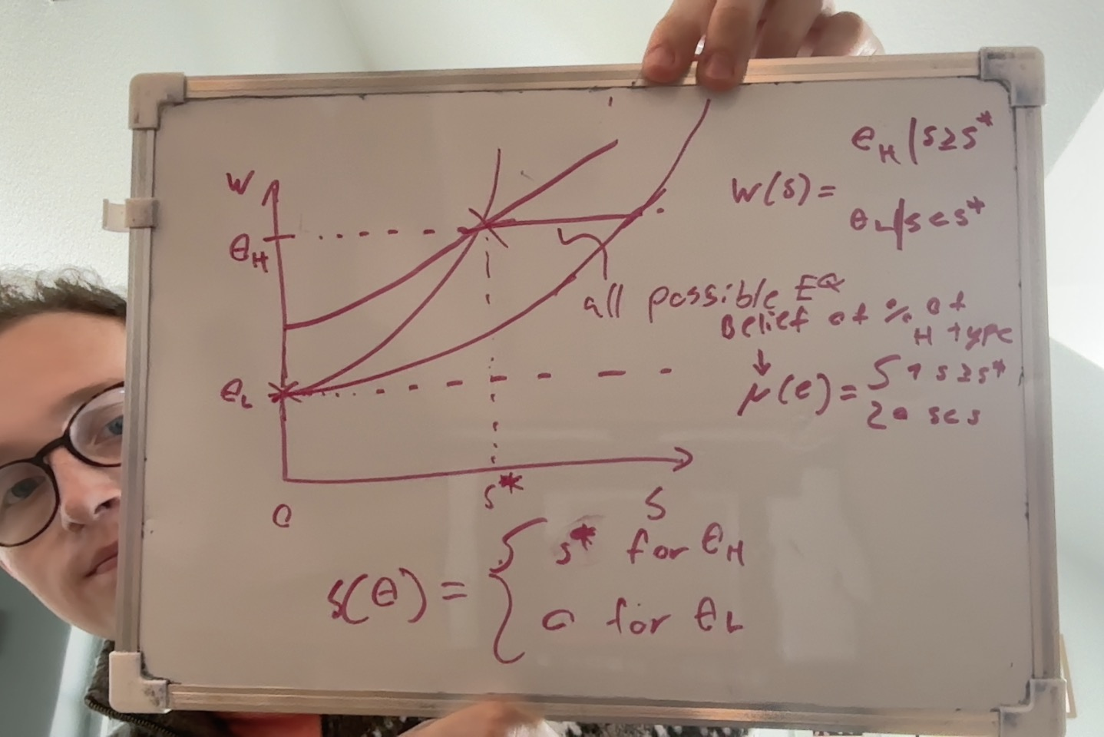

the situation where both firms offer the same contract either $(0,θ_{L})$ or $\left(s^{⋆},θ_{H}\right)$
are eq with the strategy profile and belief written on the board
the belief can be constructed in many ways as long as the firm is certain(and right) about the players type in all ”on path” decisions

- As drawn on the board
Any $\hat{s}∈[s^{⋆},s^{'}]$ where
$$θ_{L}=θ_{H}-c\left(θ_{L},s^{⋆}\right)$$
$$θ_{L}=θ_{H}-c(θ_{H},s^{'})$$
Are possible EQ with right beliefs
$$μ\left(s\right)=\left\{\begin{aligned}1 for s≥\hat{s} \\ 0 for s<\hat{s}\end{aligned}\right.$$
$$\hat{s}\left(θ\right)=\left\{\begin{aligned}\hat{s} for θ_{H} \\ 0 for θ_{L}\end{aligned}\right.$$
$$w^{⋆}\left(s\right)=\left\{\begin{aligned}θ_{H} for s≥\hat{s} \\ 0 for s<\hat{s}\end{aligned}\right.$$

The eq show in the first graph pareto dominates the others since low type gets the same utility for all of them and high type gets stricly higher utility with $s^{⋆}$ than any other eq with $s∈(s^{⋆},s^{'}]$
- Skip

- Dominance criterion: a player will never play a strictly dominated strategy this should be visible in beliefs to. If player j has a dominated strategy $m_{j}$ another player i must place 0 probability to this actions in his beliefs

Intuitive criterion: message $m_{i}$ is EQ dominated if
$$U^{⋆}\left(θ_{i}\right)>\max_{a}{U_{S}(θ_{i},m_{i},a)}$$
If a players message is EQ dominated other players must place probability 0 on this message

The intuitive criterion implies the dominance criterion it is ”Stronger”

Assignment 4

a)
Since competitive labour market we must have
$$w=θ$$
Thus a worker will work if $θ≥r(θ)$

b) yes it is pareto efficient
a firm cannot pay less as it looses the worker
a firm will not pay more as it leads to negative profits
the worker already chooses where his/her utility is largest
thus the solution is PE

c) eq workers and wages solve the following
$$θ^{⋆}=\left\{θ:w^{⋆}≥r\left(θ\right)\right\}$$
$$w^{⋆}=E[θ|θ∈θ^{⋆}]$$
Everyone who works are given the same wage and have the same reservation wage thus either everyone works or noone works
2 options either
$$w=E\left[θ\right]<r⇒θ^{⋆}=Ø⇒w^{⋆}=E\left[θ | θ∈θ^{⋆}\right]=E\left[θ\right]$$
thus this is an EQ

$$w=E\left[θ\right]≥r⇒θ^{⋆}=\left[θ_{1},θ_{2}\right]⇒w^{⋆}=\left[θ | θ∈θ^{⋆}\right]=E\left[θ\right]$$
This is the alternative EQ

These are the only 2 possibilities

d) this is a special case of the earlier setting
$$w^{⋆}=E\left[θ\right]>r⇒θ^{⋆}=\left[θ_{1},θ_{2}\right]⇒w^{⋆}=\left[θ | θ∈θ^{⋆}\right]=E\left[θ\right]$$
Yes this is pareto effecient, we can think about ways to change the relationship and see that it must be pareto
Can we increase firms utility?
Only by decreasing an employees wage which means he is worse off thus meaning not a pareto improvement

Can we increase workers utility?
Increaseing wages means decreasing firms profits thus not a pareto improvement
Since everyone is working and strictly prefer this to their outside option there is no way to increase the firms expectation without decreasing some workers utility

e)
solutions to the following
$$θ^{⋆}=\left\{θ:w^{⋆}≥r\left(θ\right)\right\}$$
$$w^{⋆}=E[θ|θ∈θ^{⋆}]$$
f)
yes just imagine
$$r\left(θ\right)=\sqrt{θ}$$
Thus the expected produktivity and thus

